Shift2Rail freight projects present their achievements in Munich

June 18, 2019

Category: [Latest News](https://shift2rail.org/news/), [newsletter7](https://shift2rail.org/newsletter7/)

**Experts working on Shift2Rail-funded projects on R&I for freight rail transport presented their results at a conference that took place on 18 June 2019 in Munich. The event clustered results from seven projects (ARCC, FR8RAIL, FR8HUB, SMART, FFL4E, M2O, INNOWAG) running under Shift2Rail’s freight innovation programme, known as IP5.**

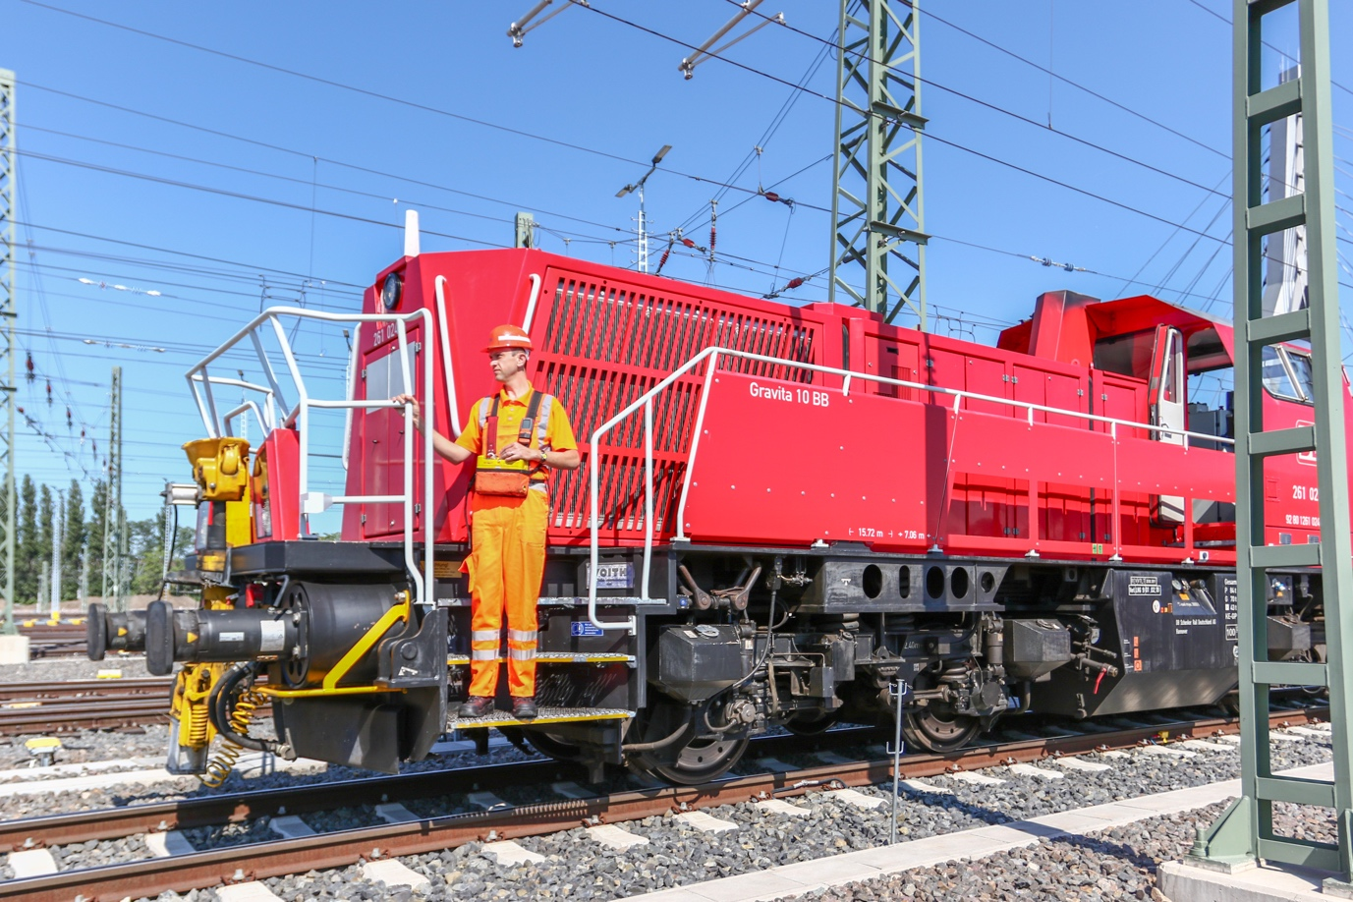

Participants had the opportunity to network and learn about the latest results of Shift2Rail R&I activities in freight rail. Innovations cover a wide spectrum of areas, ranging from new locomotive designs, longer and heavier trains, real time management of main lines and yards, intelligent freight wagon concepts, and automation and digitalisation of terminals to name but a few.

The Shift2Rail (S2R) initiative is composed of eleven ongoing and closed projects dedicated to the freight sector, including both members and non-members collaborating together under the S2R framework, a unique EU public-private partnership for rail. Shift2Rail has invested more than €48 million in these freight related projects. More than 100 universities, SMEs and large firms across Europe have participated in these Research and Innovation activities since the first project started in 2015.